**Design Document**

Online Book Store

**TEAM ALLIANCE**



**Version I**

Team Members

Jiaxing Lu (liujiaxinq@qq.com)

Kancharla Kiran Reddy ([kiran.kancharla92@gmail.com](mailto:kiran.kancharla92@gmail.com))

Christopher James (cjames1201@my.mwsu.edu)

Azharuddin Mohammed(azharuddinhussaini1989@gmail.com)

Figure 1 represents the class diagram. Basically, there are four major classes defined where the user class is being connected to all the other classes. The user class contains the user id, user name, user password and all the information about the user. The operations include adding, deleting, and updating information about the user. The book class has all the information about the books. The activities include adding new books, updating books, and deleting books as required. The manager class contains user id and password of the manager and the operations include deleting, updating, and adding books in the store. The order id class has all the information about the books ordered by the user and operations include adding, deleting, and updating the order.

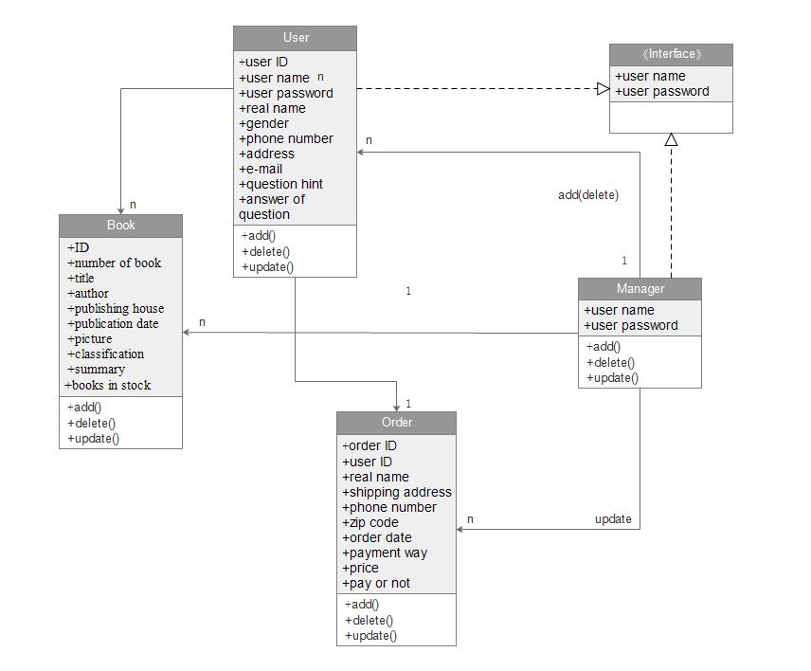

Figure 1. Class diagram of online book store

Figure 2 illustrates the final use case diagram for the online book store which we have developed.

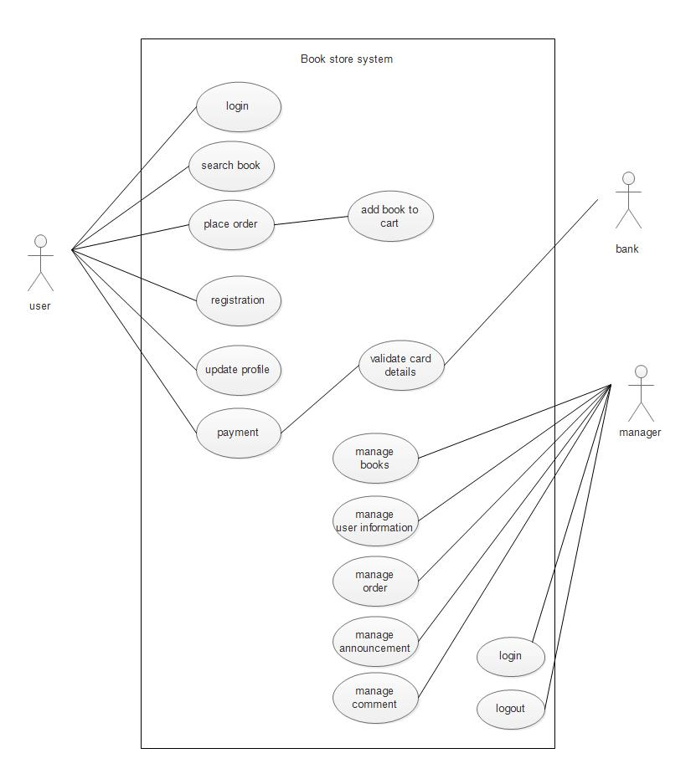

Figure 2. Use case diagram

Figure 3 illustrates the ER diagram for the online book store.

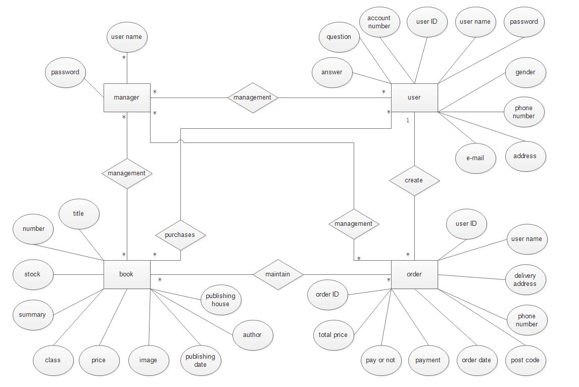

Figure 3. ER diagram.